**1.5**

**Setup Emulator or Create AVD (Android Virtual Device)**

Android virtual device (AVD) is an emulator which is used to replicate the functionality of an android phone, tablet, android wear or TV to test our android applications locally. By using AVD manager interface in android studio we can setup android virtual device emulator to test our applications.

**Create Android Virtual Device**

To test our android application we should have an Android Virtual Device (AVD). We can create virtual device by click on **AVD Manager** like as shown below.

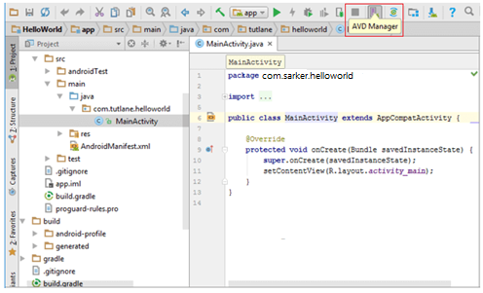

When we click on **AVD Manager**, new window will open in that click on **Create Virtual Device** like as shown below.

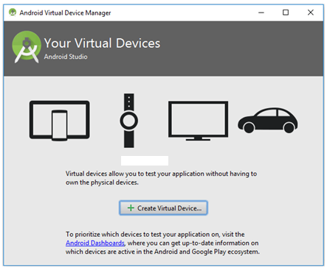

Now select the required device type and Click **Next** to create a virtual device like as shown below.

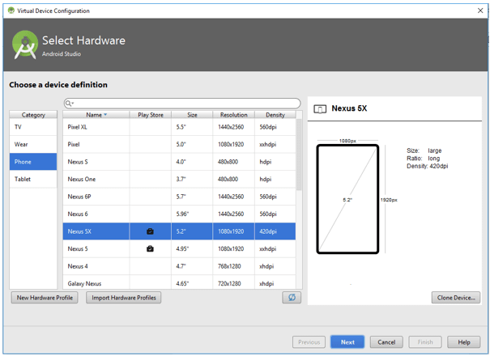

Now we need to download and select the system image and click **Next** like as shown below.

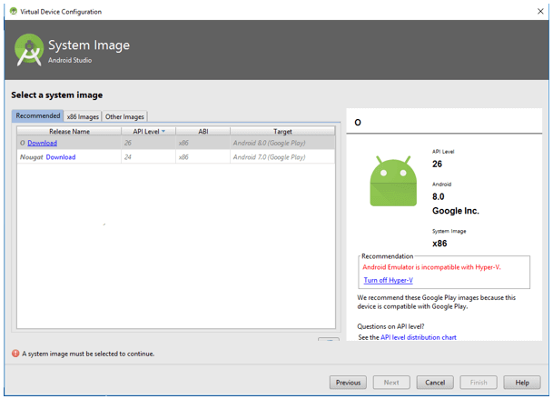

Now verify the configuration of **android virtual device** (AVD) and click **Finish** like as shown below.

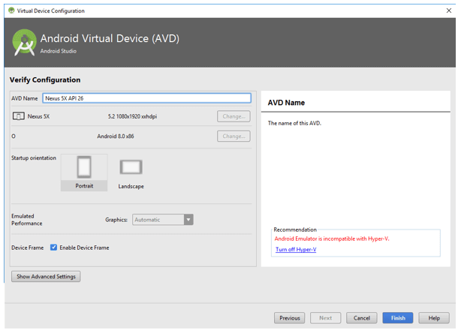

This is how we need to add android virtual device (AVD) in android studio to test our android applications.

Once we are done with setup of android virtual device in android studio, create sample application in android studio and run the app using AVD manager. In case if we are not aware of creating an app, check this [Android Hello World App](https://www.tutlane.com/tutorial/android/android-hello-world-app-example).

**Run Android Application**

To run android applications we need to click on **Run** button or press Shift + F10 like as shown below

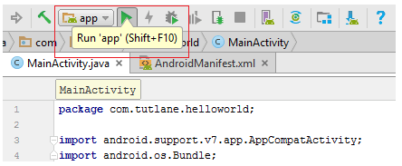

After click on play button new window will open in that select **Android Virtual Device** (AVD) and click **OK** like as shown below.

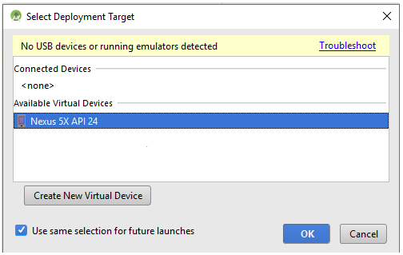

This is how we can setup android virtual device (AVD) emulator in android studio to replicate the functionality of real android devices.

**Questions**

* 1. What is Android virtual device (AVD) and how it can be setup and created in Android Studio?
  2. What are the functionality of Android Virtual Device (AVD)?